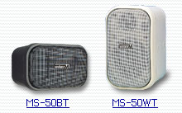

These modern design, 20W 100V line speakers reproduce Hi-Fi music to a very high standard.

 | MS-50BT | MS-50WT
Rated Output | 50W/4ohm, 20V/100V
Frequency Response | 120Hz - 20kHz
SPL (1W /1m) | 90dB
Colour | Black | Off White
Weight | 3.2kg
Dimensions | 150(W) x 240(H) x 150(D)mm
Bracket (Option) | FSB-1

